MODULE -2

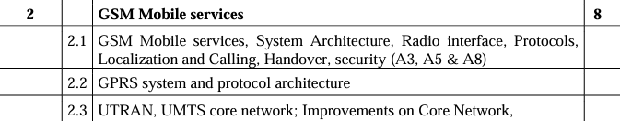

IMPORTANT QUESTIONS

Q1. What is the use of different interfaces used in the GSM with diagram

In GSM (Global System for Mobile Communications), various interfaces are used to facilitate communication between different network components. These interfaces standardize interactions, ensuring compatibility and efficient operation across the network. Here’s an overview of the key interfaces in GSM, their uses, and a diagram to illustrate their connections.

### Key Interfaces in GSM

1. **Um Interface**:

- **Description**: The air interface between the Mobile Station (MS) and the Base Transceiver Station (BTS).

- **Use**: Facilitates wireless communication between the mobile device and the network, handling radio signals and protocols for voice and data transmission.

2. **Abis Interface**:

- **Description**: The interface between the BTS and the Base Station Controller (BSC).

- **Use**: Transmits control and traffic information. It manages the radio resources and handles low-level operations such as channel coding and decoding.

3. **A Interface**:

- **Description**: The interface between the BSC and the Mobile Switching Center (MSC).

- **Use**: Carries voice, data, and signaling information. It handles call setup, routing, and mobility management.

4. **B Interface**:

- **Description**: The interface between the MSC and the Visitor Location Register (VLR).

- **Use**: Facilitates the exchange of subscriber information and manages location updates, authentication, and call routing for roaming users.

5. **C Interface**:

- **Description**: The interface between the MSC and the Home Location Register (HLR).

- **Use**: Manages the retrieval and update of subscriber information stored in the HLR, including user profiles, authentication parameters, and service subscriptions.

6. **D Interface**:

- **Description**: The interface between the HLR and the VLR.

- **Use**: Handles the transfer of subscriber data and mobility management information between the HLR and VLR during roaming.

7. **E Interface**:

- **Description**: The interface between the MSC and the Gateway MSC (GMSC).

- **Use**: Manages the routing of calls and messages from external networks into the GSM network and vice versa.

8. **F Interface**:

- **Description**: The interface between the MSC and the Short Message Service Center (SMSC).

- **Use**: Facilitates the delivery of short messages (SMS) to and from the mobile station.

9. **G Interface**:

- **Description**: The interface between two MSCs.

- **Use**: Supports inter-MSC handovers and roaming by transferring call control and subscriber information.

10. **H Interface**:

- **Description**: The interface between the MSC and the Authentication Center (AUC).

- **Use**: Manages the authentication of subscribers and the generation of encryption keys for secure communication.

11. **I Interface**:

- **Description**: The interface between the MSC and the Equipment Identity Register (EIR).

- **Use**: Checks the validity of the mobile equipment by verifying its International Mobile Equipment Identity (IMEI) to prevent the use of stolen or unauthorized devices.

### Diagram of GSM Network Interfaces

Here's a simplified diagram showing the various interfaces and their connections in a GSM network:

```plaintext

+------------------------+

| PSTN/PLMN |

+-----------+------------+

|

(E)

|

v

+------------------------+

| GMSC |

+-----------+------------+

|

(E)

|

v

+------------------------+

| MSC |

+---+---+---+---+---+----+

| | | | | |

(A) (B) (C) (F) (H) (I)

| | | | | |

v v v v v v

+----+ +---+ +---+ +---+ +---+

|BSC | |VLR| |HLR| |SMSC| |AUC| |EIR|

+----+ +---+ +---+ +---+ +---+ +---+

|

(Abis)

|

v

+----+

| BTS|

+----+

|

(Um)

|

v

+----+

| MS |

+----+

```

### Explanation of Interfaces:

1. **Um Interface**:

- **Between**: MS (Mobile Station) and BTS (Base Transceiver Station).

- **Use**: Handles wireless communication between the mobile device and the network.

2. **Abis Interface**:

- **Between**: BTS and BSC (Base Station Controller).

- **Use**: Transmits control and traffic information between the BTS and BSC.

3. **A Interface**:

- **Between**: BSC and MSC (Mobile Switching Center).

- **Use**: Carries voice, data, and signaling information.

4. **B Interface**:

- **Between**: MSC and VLR (Visitor Location Register).

- **Use**: Manages location updates, authentication, and call routing for roaming users.

5. **C Interface**:

- **Between**: MSC and HLR (Home Location Register).

- **Use**: Manages the retrieval and update of subscriber information.

6. **D Interface**:

- **Between**: HLR and VLR.

- **Use**: Transfers subscriber data and mobility management information during roaming.

7. **E Interface**:

- **Between**: MSC and GMSC (Gateway MSC).

- **Use**: Routes calls and messages between external networks and the GSM network.

8. **F Interface**:

- **Between**: MSC and SMSC (Short Message Service Center).

- **Use**: Facilitates SMS delivery to and from the mobile station.

9. **G Interface**:

- **Between**: Two MSCs.

- **Use**: Supports inter-MSC handovers and roaming.

10. **H Interface**:

- **Between**: MSC and AUC (Authentication Center).

- **Use**: Manages subscriber authentication and encryption.

11. **I Interface**:

- **Between**: MSC and EIR (Equipment Identity Register).

- **Use**: Verifies the validity of mobile equipment by checking the IMEI.

These interfaces ensure seamless operation and communication across different components of the GSM network, enabling efficient call setup, mobility management, authentication, and service delivery.

Q2. What are different security algorithms used in GSM

Q3. Which components are new in GPRS as compared to GSM? What is their purpose.

General Packet Radio Service (GPRS) extends the capabilities of GSM (Global System for Mobile Communications) to support packet-switched data, enabling efficient mobile internet access and other data services. Several new components are introduced in the GPRS architecture to achieve this functionality. Here are the main components that are added to the existing GSM infrastructure and their purposes:

### 1. Serving GPRS Support Node (SGSN)

**Purpose**:

- The SGSN is responsible for delivering data packets to and from the mobile stations within its service area.

- It performs mobility management functions such as user authentication, session management, and maintaining location information.

- It keeps track of individual mobile devices' locations, similar to the MSC in GSM, but specifically for packet-switched data.

### 2. Gateway GPRS Support Node (GGSN)

**Purpose**:

- The GGSN acts as an interface between the GPRS network and external packet-switched networks such as the internet or other IP-based networks.

- It routes data packets between the GPRS network and external networks, translating GPRS packets into the appropriate format for the destination network.

- The GGSN also handles tasks like IP address allocation for mobile devices and acts as a gateway that aggregates multiple SGSNs.

### 3. Packet Control Unit (PCU)

**Purpose**:

- The PCU is typically integrated with the Base Station Controller (BSC) and is responsible for the radio resource management for packet-switched data.

- It manages the allocation of radio channels and the scheduling of data transmissions for GPRS services.

- The PCU ensures efficient use of the radio spectrum for both voice and data services.

### 4. GPRS Tunneling Protocol (GTP)

**Purpose**:

- GTP is a protocol used for carrying user data and control messages between the SGSN and the GGSN.

- It encapsulates data packets and tunnels them through the GPRS core network, ensuring they reach the correct destination.

- GTP provides mobility support, allowing data sessions to continue uninterrupted as users move across different network areas.

### 5. HLR Enhancements

**Purpose**:

- The Home Location Register (HLR) in GSM is enhanced to store GPRS-specific information, such as the GPRS subscription details and user profiles.

- It includes information about the services a user is subscribed to and their access rights for GPRS services.

### GPRS Architecture Diagram

Here's a simplified diagram of the GPRS architecture, highlighting the new components and their integration with existing GSM elements:

```plaintext

+-----------------------+

| Internet |

+-----------+-----------+

|

(Gi)

|

v

+-----------------------+

| GGSN |

+-----------+-----------+

|

(Gn)

|

v

+-----------------------+

| SGSN |

+-----------+-----------+

|

(Gb)

|

v

+-----------------------+

| BSC |

+-----------+-----------+

|

(Abis)

|

v

+-----------------------+

| BTS |

+-----------+-----------+

|

(Um)

|

v

+-----------------------+

| MS |

+-----------------------+

```

### Explanation of Interfaces:

- **Gi**: Interface between the GGSN and external IP networks like the internet.

- **Gn**: Interface between the SGSN and the GGSN within the GPRS core network.

- **Gb**: Interface between the SGSN and the BSC, used for transmitting GPRS data.

- **Um**: Air interface between the mobile station (MS) and the BTS, same as in GSM.

- **Abis**: Interface between the BTS and the BSC, used for both voice and data in GPRS.

### Conclusion

The introduction of the SGSN, GGSN, PCU, and GTP, along with enhancements to existing components like the HLR, transforms the GSM network into a system capable of handling packet-switched data efficiently. This extension allows GSM networks to support mobile internet access and other data services, laying the groundwork for modern mobile data communication.

* GSM Architecture and components
* Handover/ Handoffs in GSM
* Security (A3, A5 , A8) & Privacy
* UMTS Core Network (UTRAN)
* GPRS vs GSM

PYQ

Q1. Explain in short different algorithm used for authentication and privacy in GSM- 10M

Q2. What is the use of different interfaces used in global system for mobile communication (GSM) with diagram?- 10M (x2)

Q3. Which components are new in GPRS as compared to GSM? What is there purpose? – 10M

Q4.explain GSM system architecture in detail || Q9. Explain in detail GSM architecture.(x2) – 10M

Q5. Why is it necessary to have handover mechanism in GSM? Explain possible handover scenarios in short

Q6. List various security services offered by GSM. Explain A3 A5 A8 algorithm in brief

Q7. What are different security algorithms used in GSM?-10M

Q8. Explain characteristics of GSM standards – 5M

The GSM (Global System for Mobile Communications) standards encompass a set of characteristics that define the technical specifications and operational parameters of the GSM network. These characteristics are instrumental in enabling efficient mobile communication across the GSM network. Here are the key characteristics of GSM standards:

### 1. Digital Technology:

GSM is based on digital technology, which offers several advantages over analog systems, including improved voice quality, enhanced security, and efficient spectrum utilization. Digital transmission also allows for more advanced features and services.

### 2. Time Division Multiple Access (TDMA):

GSM employs TDMA, a digital modulation technique that divides the frequency spectrum into time slots, allowing multiple users to share the same channel. TDMA enables efficient utilization of radio resources and supports multiple simultaneous calls on a single radio frequency.

### 3. Frequency Reuse:

GSM utilizes a cellular network architecture with frequency reuse patterns. The available frequency spectrum is divided into smaller cells, and the same frequencies can be reused in different cells that are sufficiently far apart to minimize interference. This maximizes the capacity and coverage of the network.

### 4. Handover and Roaming:

GSM supports seamless handover between different cells and networks, allowing mobile users to maintain ongoing calls or data sessions while moving between coverage areas. Additionally, GSM enables international roaming, allowing subscribers to use their mobile devices in different countries with interoperable networks.

### 5. Support for Multiple Services:

GSM is designed to support a wide range of services beyond voice calls, including Short Message Service (SMS), multimedia messaging (MMS), data transmission (e.g., GPRS), and packet-switched services (e.g., internet access). This versatility makes GSM a versatile platform for various communication needs.

### 6. Standardization:

GSM standards are developed and maintained by various standardization bodies, including the European Telecommunications Standards Institute (ETSI) and the 3rd Generation Partnership Project (3GPP). Standardization ensures interoperability between different network elements and equipment from various manufacturers, promoting a competitive marketplace and innovation.

### 7. Security Features:

GSM incorporates robust security mechanisms to protect user privacy and prevent unauthorized access. These include subscriber authentication, encryption of voice and data transmissions, and the use of unique identifiers such as International Mobile Subscriber Identity (IMSI) and Temporary Mobile Subscriber Identity (TMSI) to authenticate and track subscribers.

### 8. Efficient Network Management:

GSM networks feature sophisticated network management capabilities for monitoring and controlling network performance, optimizing resource allocation, and troubleshooting issues. This ensures reliable and high-quality service for subscribers while minimizing operational costs for network operators.

### 9. Evolution and Compatibility:

GSM standards have evolved over time to support higher data rates, new services, and improved efficiency. The GSM family of standards, including GPRS (General Packet Radio Service), EDGE (Enhanced Data Rates for GSM Evolution), and UMTS (Universal Mobile Telecommunications System), builds upon the foundation of GSM while providing backward compatibility to ensure seamless migration and interoperability.

### Conclusion:

The characteristics of GSM standards combine to create a robust, efficient, and versatile mobile communication system that has become the foundation for global mobile networks. With its digital technology, efficient spectrum utilization, support for multiple services, and strong security features,GSM continues to be a dominant force in the telecommunications industry, serving billions of users worldwide.

Q11. Explain the network and switching sub system of GSM architecture

Q12. GSM maintains end-to-end security by retaining the confidentiality of calls and anonymity of GSM subscriber . Justify this statement

The statement that "GSM maintains end-to-end security by retaining the confidentiality of calls and anonymity of GSM subscribers" can be justified by examining the security features and mechanisms implemented within the GSM network:

### 1. Encryption:

GSM incorporates encryption mechanisms to protect the confidentiality of voice calls and data transmissions. Encryption algorithms, such as the A5 series, are used to encode voice and data traffic between the mobile station (MS) and the base station (BTS). This encryption prevents unauthorized interception of communication, ensuring that only authorized parties can decode and understand the transmitted information.

### 2. Subscriber Authentication:

GSM employs subscriber authentication mechanisms to verify the identity of mobile subscribers before granting access to network services. Each subscriber is assigned a unique identifier, known as the International Mobile Subscriber Identity (IMSI), which is stored on the subscriber's SIM card. During network registration, the subscriber's identity is authenticated using a challenge-response mechanism, involving the exchange of authentication tokens between the mobile station and the network's authentication center (AUC). This authentication process ensures that only legitimate subscribers can access network resources and services.

### 3. Anonymity of GSM Subscribers:

GSM protects the anonymity of subscribers by assigning temporary identifiers, known as Temporary Mobile Subscriber Identities (TMSIs), during communication sessions. TMSIs are randomly generated and periodically updated by the network to prevent tracking of subscribers' movements and activities. Instead of transmitting the IMSI, which could be intercepted and used to track a subscriber's location and behavior, the mobile station uses the TMSI for communication within the network. This enhances subscriber privacy and anonymity, making it difficult for unauthorized parties to identify and monitor individual subscribers.

### 4. Secure Network Infrastructure:

GSM network infrastructure components, such as the Mobile Switching Center (MSC), Home Location Register (HLR), and Authentication Center (AUC), are equipped with security measures to safeguard against unauthorized access and attacks. Access to network elements is restricted through authentication and authorization mechanisms, and communication between network elements is encrypted to prevent eavesdropping and tampering.

### Conclusion:

By incorporating encryption, subscriber authentication, anonymous identifiers, and secure network infrastructure, GSM maintains end-to-end security to protect the confidentiality of calls and preserve the anonymity of GSM subscribers. These security features work together to ensure that communication within the GSM network remains private, secure, and accessible only to authorized parties, thereby instilling trust in the integrity of the network and enhancing user confidence in mobile communication services.

Q13. Explain the GPRS architecture in detail. Compare it with GSM architecture

Q14. Short note on : GSM Burst structure

The GSM (Global System for Mobile Communications) burst structure is a fundamental element of the GSM air interface, defining how data is transmitted between the mobile station (MS) and the base station (BTS) in the GSM network. It consists of a series of bits organized into specific time slots within a radio frame, allowing for efficient transmission of voice and data.

### Key Components of GSM Burst Structure:

1. **Timeslot**:

- Each burst is transmitted within a fixed time slot, typically lasting 0.577 milliseconds, as defined by the GSM standard.

- Time division multiple access (TDMA) is used to allocate different time slots to multiple users within the same frequency channel.

2. **Synchronization Burst**:

- The first burst in each time slot is the synchronization burst, which contains information to help synchronize the mobile station with the base station.

- It includes training sequences and a unique bit pattern known as the Frequency Correction Burst (FCCH) to assist in frequency synchronization.

3. **Normal Burst**:

- Following the synchronization burst, the normal burst contains the actual user data, such as speech samples or signaling information.

- It consists of encrypted voice or data bits, error correction coding, and a training sequence for equalization at the receiver.

4. **Guard Period**:

- A guard period separates adjacent bursts to prevent interference and ensure reliable reception.

- It provides a brief interval of silence between bursts to mitigate the effects of multipath propagation and allow for accurate signal detection.

### Benefits of GSM Burst Structure:

- **Efficient Spectrum Utilization**: TDMA enables multiple users to share the same frequency channel by dividing it into time slots, maximizing the capacity and efficiency of the GSM network.

- **Robustness Against Interference**: The guard period between bursts helps reduce interference from adjacent channels and multipath propagation, improving the reliability of communication.

- **Synchronization and Timing**: The synchronization burst provides essential timing and frequency information, allowing mobile stations to synchronize with the base station and maintain accurate timing for transmission and reception.

- **Compatibility and Interoperability**: The standardized burst structure ensures compatibility and interoperability between different GSM network components and mobile devices from various manufacturers.

### Conclusion:

The GSM burst structure plays a crucial role in facilitating efficient and reliable communication within the GSM network. By organizing data into synchronized bursts within specific time slots, GSM optimizes spectrum utilization, enhances robustness against interference, and enables accurate timing and synchronization between mobile stations and base stations. This standardized burst structure is essential for the seamless operation of GSM networks, supporting a wide range of voice and data services for millions of mobile subscribers worldwide.

Q15.Short note on: GPRS network nodes

General Packet Radio Service (GPRS) network nodes are key components of the GPRS infrastructure, designed to enable packet-switched data transmission over GSM networks. These nodes work together to facilitate efficient data communication, mobile internet access, and support for various IP-based services. Here's a brief overview of the main GPRS network nodes:

### 1. Serving GPRS Support Node (SGSN):

- **Function**: The SGSN is responsible for managing the data packet delivery to and from the mobile stations (MS) within its service area.

- **Key Tasks**:

- Packet routing and forwarding.

- Mobility management, including user authentication, location tracking, and handover management.

- Quality of Service (QoS) enforcement and resource allocation.

- **Location**: Each SGSN serves a specific geographic area, overlapping with one or more base stations.

### 2. Gateway GPRS Support Node (GGSN):

- **Function**: The GGSN serves as the interface between the GPRS network and external packet-switched networks, such as the internet or corporate intranets.

- **Key Tasks**:

- Routing of data packets between the GPRS network and external networks.

- IP address allocation and management for mobile devices.

- Packet filtering and firewall functionalities.

- **Location**: Typically located at the edge of the GPRS network, connecting to various external networks via IP-based interfaces.

### 3. Packet Control Unit (PCU):

- **Function**: The PCU is responsible for managing the radio resources and handling packet-switched data transmission within the base station subsystem (BSS).

- **Key Tasks**:

- Packet scheduling and radio resource allocation to optimize bandwidth utilization.

- Error detection and correction for data transmission over the air interface.

- Protocol conversion between the radio interface and the core network.

- **Location**: Typically integrated within the base station controller (BSC) or the base transceiver station (BTS).

### 4. GPRS Tunneling Protocol (GTP):

- **Function**: GTP is a protocol suite used for carrying user data and control messages between different GPRS network nodes.

- **Key Tasks**:

- Encapsulation and tunneling of GPRS packets between the SGSN and the GGSN.

- Support for mobility management and session continuity during handovers.

- **Location**: Implemented as part of the SGSN, GGSN, and other network elements involved in packet routing.

### Conclusion:

GPRS network nodes play vital roles in enabling packet-switched data communication over GSM networks, providing users with access to mobile internet, email, multimedia messaging, and other IP-based services. By managing packet routing, resource allocation, and interface connectivity, these nodes form the backbone of the GPRS infrastructure, ensuring efficient and reliable data transmission for millions of mobile subscribers worldwide.

Q16. What is GPRS? describe its architecture in detail

Q17. explain GSM in detai

| **Aspect** | **GPRS** | **GSM** |
| --- | --- | --- |
| **1. Full Form** | General Packet Radio Service | Global System for Mobile Communications |
| **2. Purpose** | Enables packet-switched data transmission | Provides voice and data services |
| **3. Data Transmission** | Packet-switched | Circuit-switched |
| **4. Data Rate** | Higher data rates (up to Mbps) | Lower data rates (up to Kbps) |
| **5. Connection Type** | Always-on | On-demand |
| **6. Billing** | Based on volume of data transferred | Based on call duration or messages sent |
| **7. Network Architecture** | Adds packet-switched capabilities to GSM | Original voice-centric network structure |
| **8. Resource Allocation** | Dynamically allocates resources per use | Static allocation for voice calls |
| **9. Packet Headers** | Include additional routing and control info | Primarily contain voice or data payload |
| **10. QoS Support** | Supports differentiated QoS for applications | Limited QoS support, primarily for voice |
| **11. Service Types** | Enables internet access, email, and multimedia messaging | Voice calls, SMS, and basic data services |
| **12. Protocol Stack** | Includes TCP/IP stack for internet connectivity | Primarily uses GSM protocols for communication |
| **13. Session Continuity** | Supports seamless handovers between cells for data sessions | Handovers primarily designed for voice calls |
| **14. Network Nodes** | Includes SGSN, GGSN, PCU, and GTP for packet routing | Consists of BTS, BSC, MSC, and other GSM elements |
| **15. Evolution** | Evolved to support technologies like EDGE and UMTS | Continued evolution with technologies like LTE and 5G |

Q18. Short note on: Authentication and privacy in GSM || Q1. Explain in short different algorithm used for authentication and privacy in GSM- 10M || Q6. List various security services offered by GSM. Explain A3 A5 A8 algorithm in brief || Q7. What are different security algorithms used in GSM?-10M || Q10. Explain in short different algorithm used for authentication and privacy in GSM – 10M || Q2. What are different security algorithms used in GSM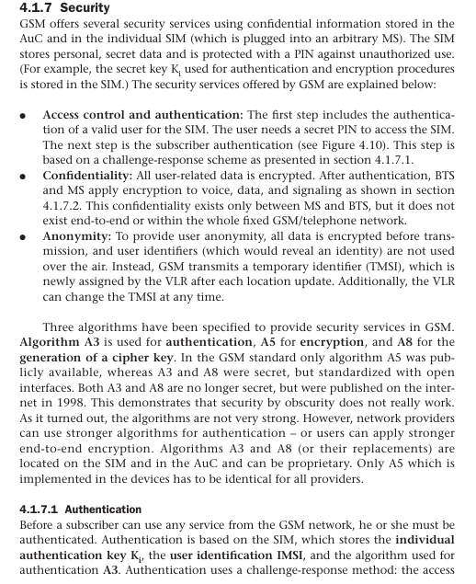

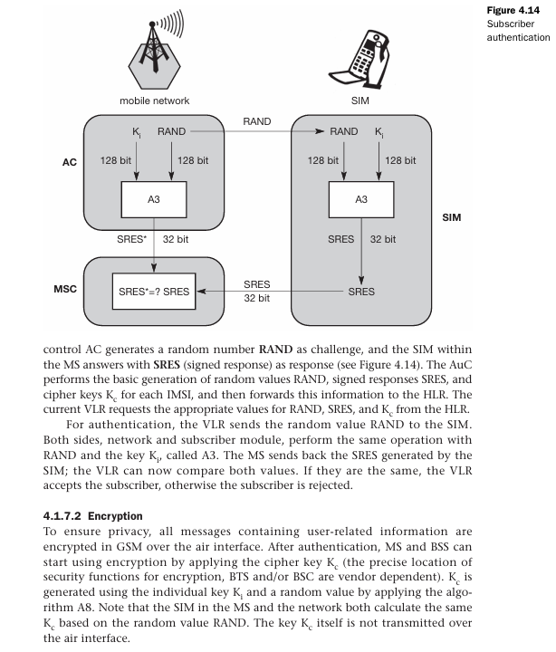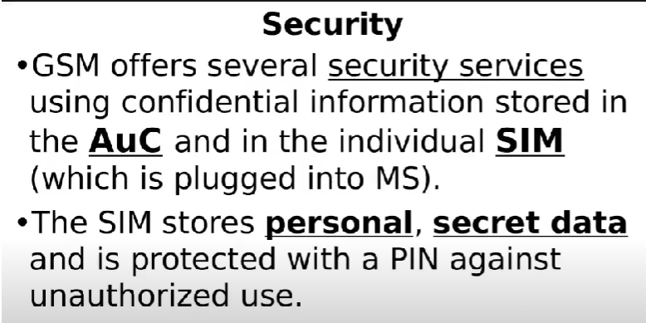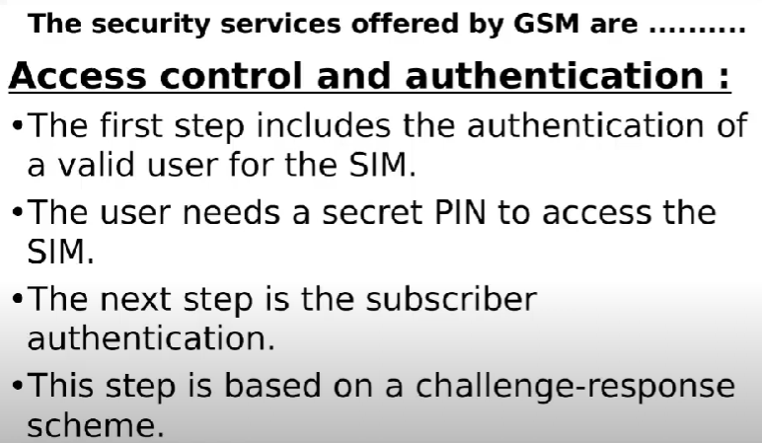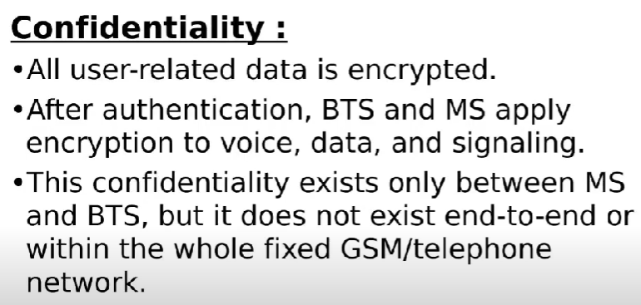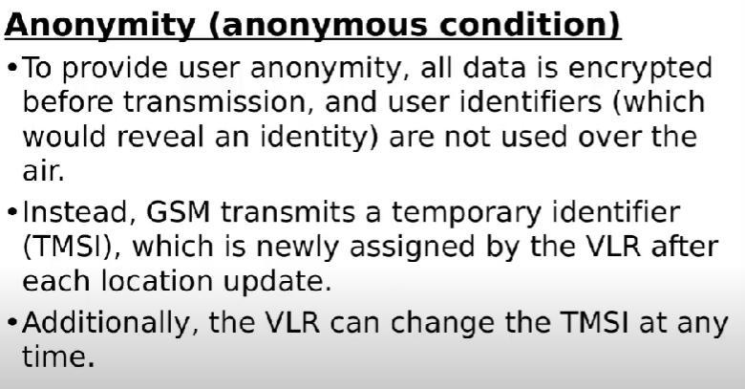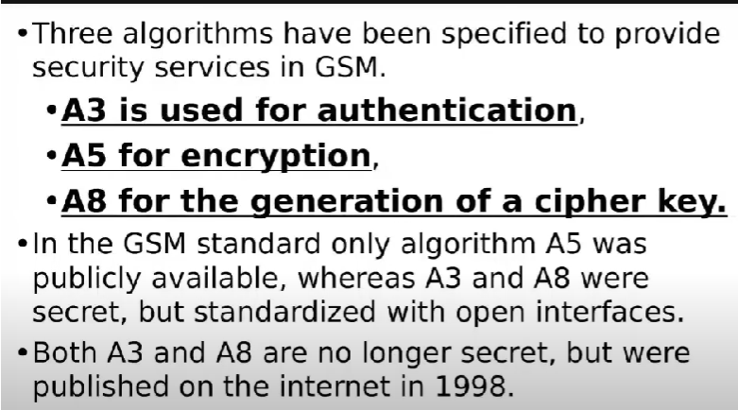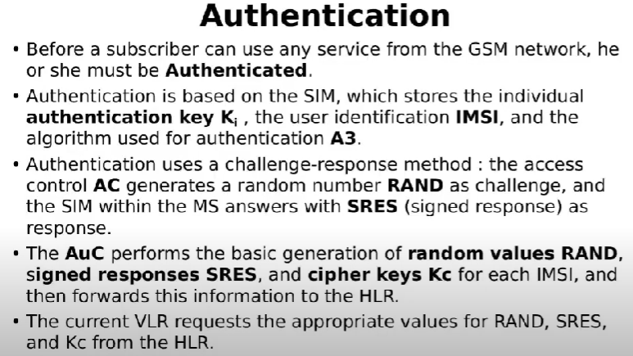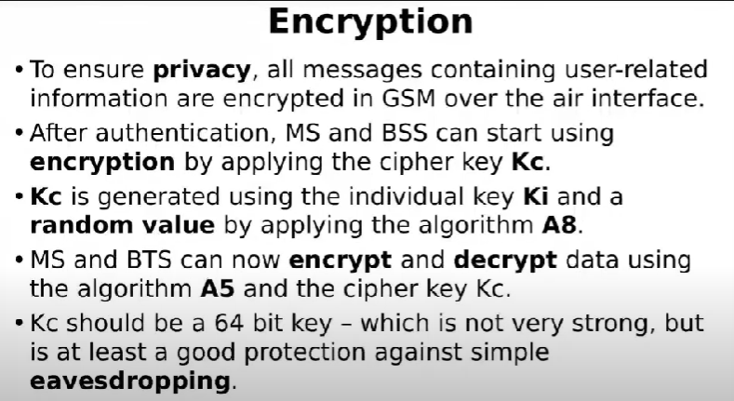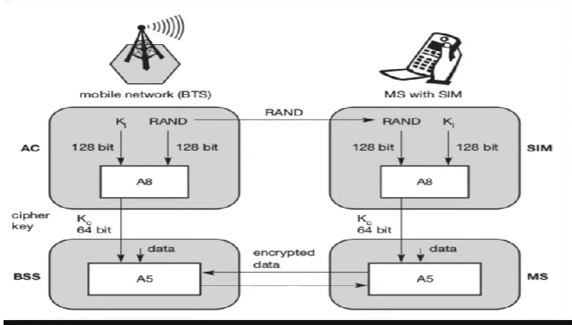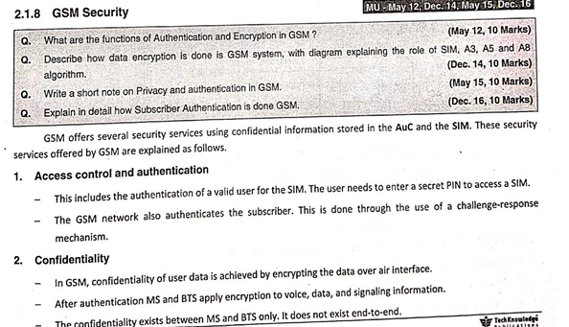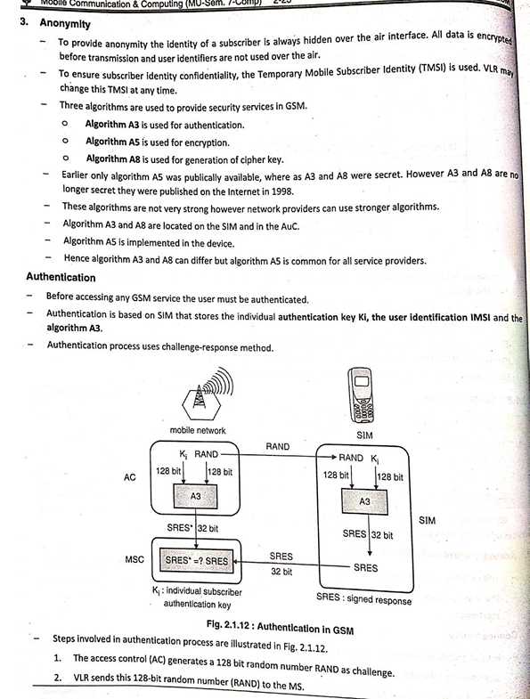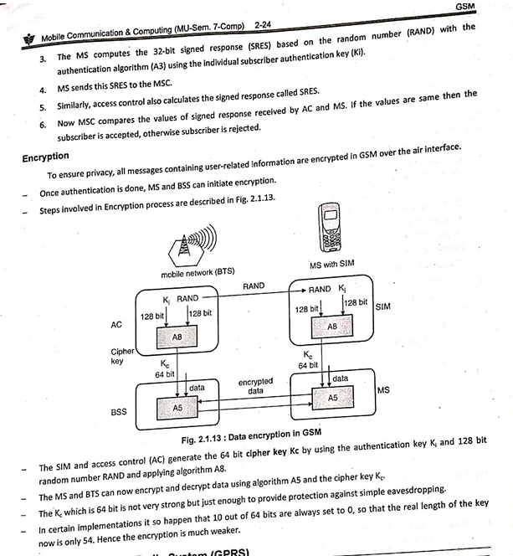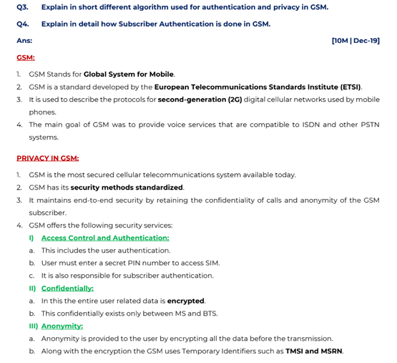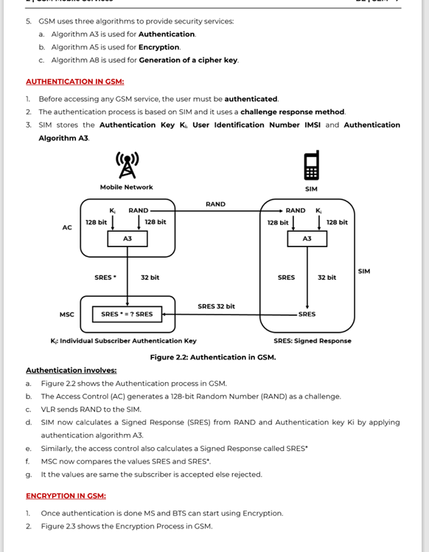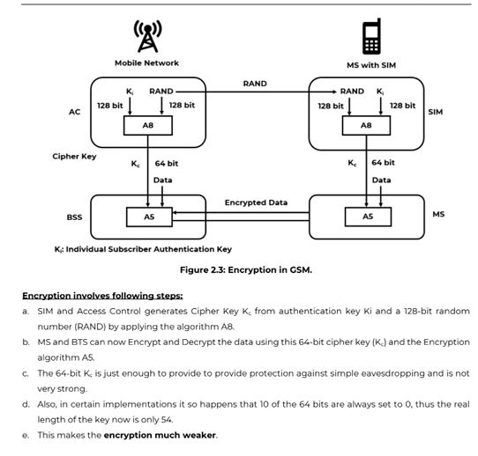

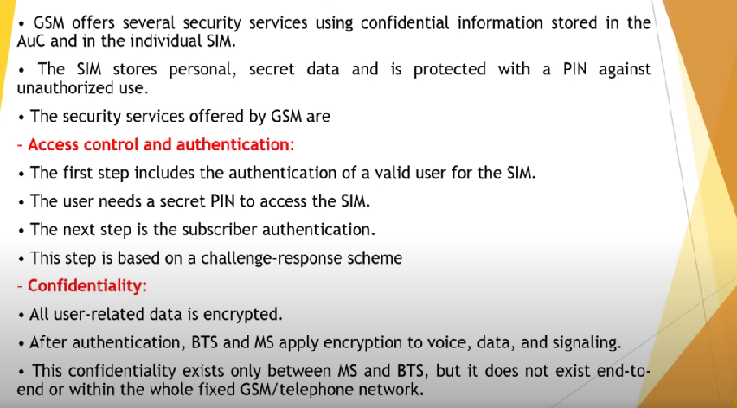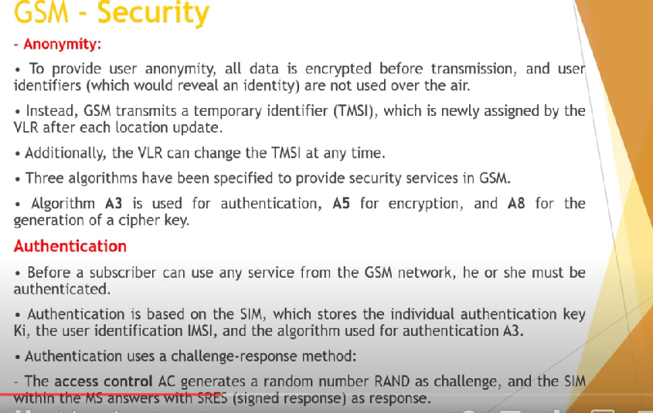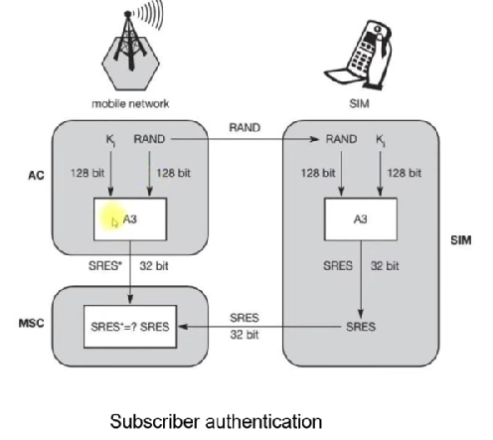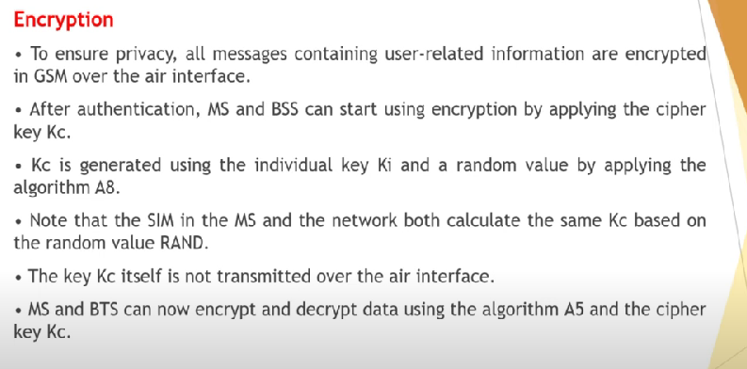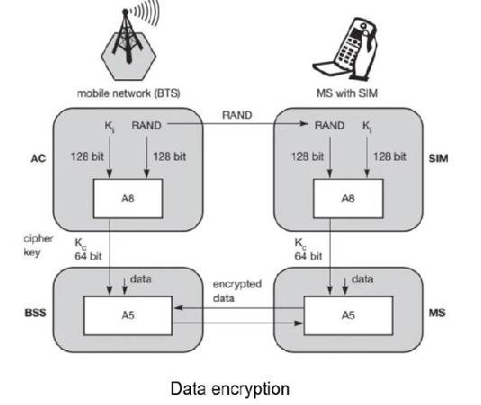

Q5. Why is it necessary to have handover mechanism in GSM? Explain possible handover scenarios in short

### Importance of Handover Mechanism in GSM

In GSM (Global System for Mobile Communications), the handover mechanism is crucial for maintaining seamless connectivity and service continuity as a mobile user moves through different coverage areas. The handover process ensures that an ongoing call or data session is not dropped when the user moves from one cell (or Base Transceiver Station, BTS) to another. Here’s why it is necessary:

1. **Mobility Management**:

- Mobile users frequently move, and the handover mechanism allows them to maintain their active sessions while traversing different cell boundaries.

2. **Quality of Service**:

- Ensures that the user experiences minimal disruption, maintaining call quality and data transfer rates.

3. **Load Balancing**:

- Distributes the network load evenly by transferring users to cells with more available resources, preventing congestion in any single cell.

4. **Interference Reduction**:

- Helps reduce co-channel and adjacent channel interference by dynamically adjusting the user's connection to the optimal cell.

### Possible Handover Scenarios in GSM

GSM supports several types of handovers, each designed for specific situations. The main handover scenarios are:

#### 1. **Intra-Cell Handover**

- **Scenario**: Occurs within the same cell.

- **Purpose**: Typically used to resolve interference issues or to shift a user to a different channel within the same cell to improve connection quality.

- **Example**: A user experiencing interference on a specific frequency channel within a cell is handed over to another frequency within the same cell.

#### 2. **Inter-Cell Handover**

- **Scenario**: Occurs between different cells but within the same Base Station Controller (BSC) area.

- **Purpose**: Facilitates user movement from one cell to another, maintaining the connection as the user moves.

- **Example**: A user moving from the coverage area of BTS1 to BTS2 within the same BSC’s control.

#### 3. **Inter-BSC Handover**

- **Scenario**: Occurs between cells controlled by different BSCs but within the same Mobile Switching Center (MSC) area.

- **Purpose**: Allows the user to move across larger areas covered by different BSCs without dropping the connection.

- **Example**: A user moving from the coverage of BTS1 under BSC1 to the coverage of BTS2 under BSC2, both managed by the same MSC.

#### 4. **Inter-MSC Handover**

- **Scenario**: Occurs between cells managed by different MSCs.

- **Purpose**: Facilitates movement across regions or network areas managed by different MSCs, ensuring wide-area mobility.

- **Example**: A user traveling from one city to another, moving from an area managed by MSC1 to an area managed by MSC2.

### Detailed Process of Handover

1. **Measurement Reports**:

- The mobile station (MS) continuously sends measurement reports to the serving BTS, including signal strengths of neighboring cells.

2. **Decision Making**:

- The network (BSC/MSC) evaluates the measurement reports and decides if a handover is necessary based on predefined criteria such as signal strength thresholds, quality, and load conditions.

3. **Preparation**:

- The target cell (new BTS) is prepared for the incoming handover. This involves allocating necessary resources (channels, timeslots, etc.).

4. **Execution**:

- The serving BTS commands the MS to switch to the new cell’s frequency and channel. The MS synchronizes with the new BTS.

5. **Completion**:

- The new BTS takes over the communication, and the old BTS releases the resources. The handover is now complete.

### Conclusion

The handover mechanism in GSM is essential for providing uninterrupted service and maintaining high-quality communication as users move through different areas. It accommodates various scenarios, from simple intra-cell adjustments to complex inter-MSC transitions, ensuring seamless connectivity across the network.

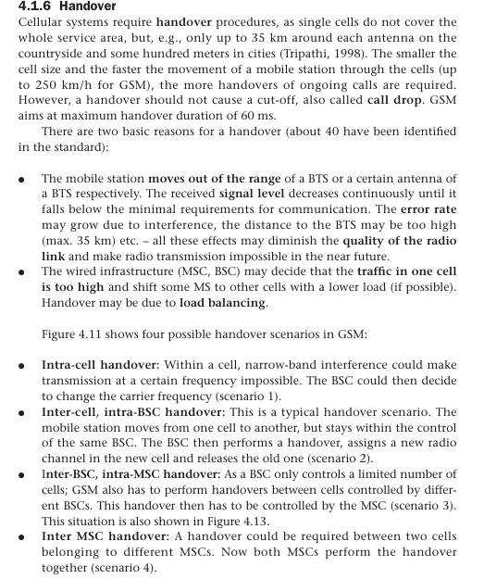

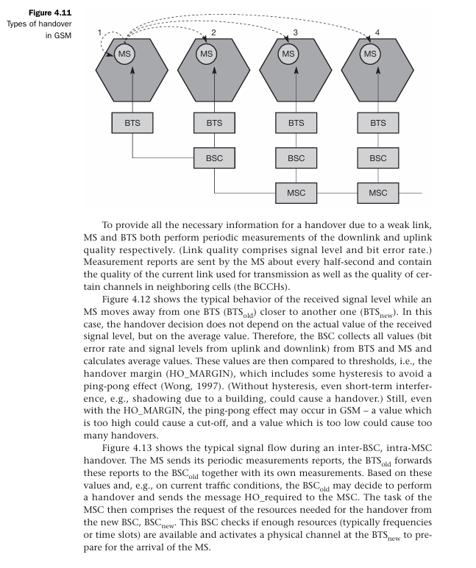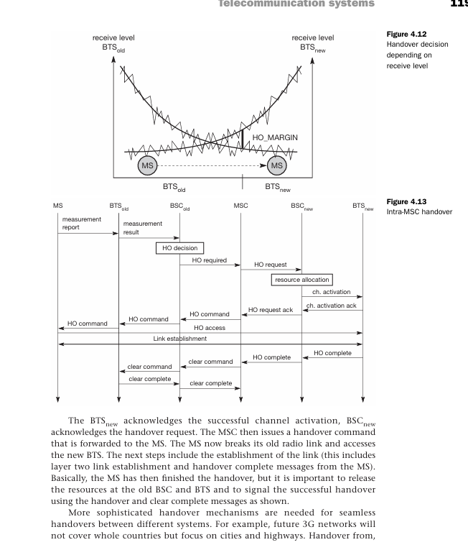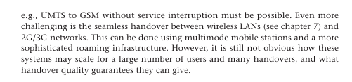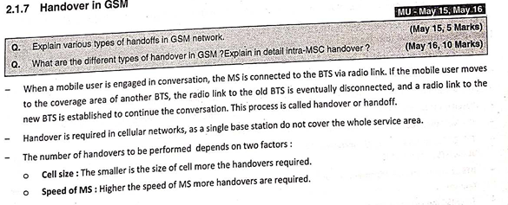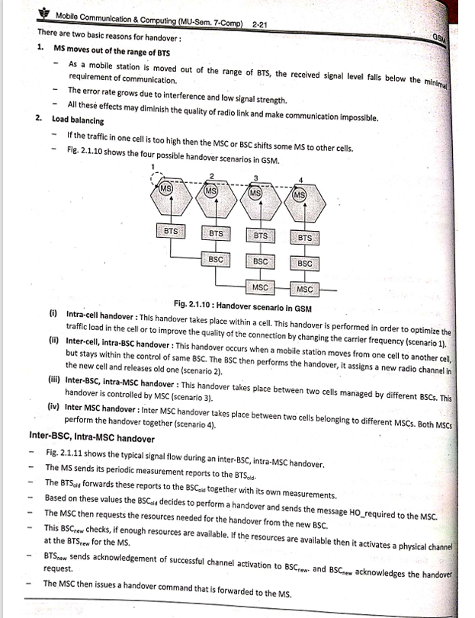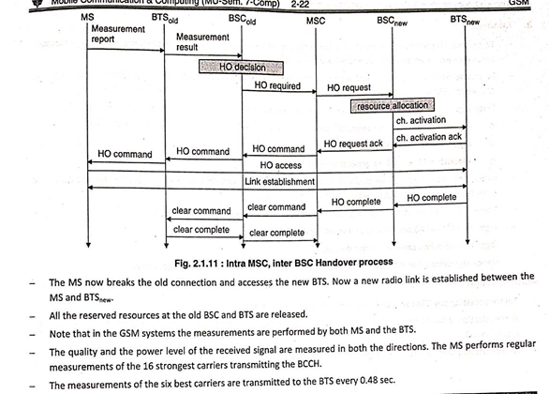

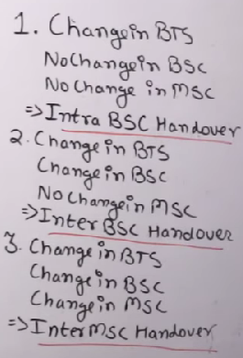

GSM

